Assignment 4- PyMongo and MongoDB

Output and Plots
b)
Terminal Output:
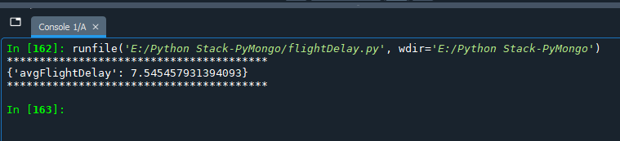

c)
Terminal Output:
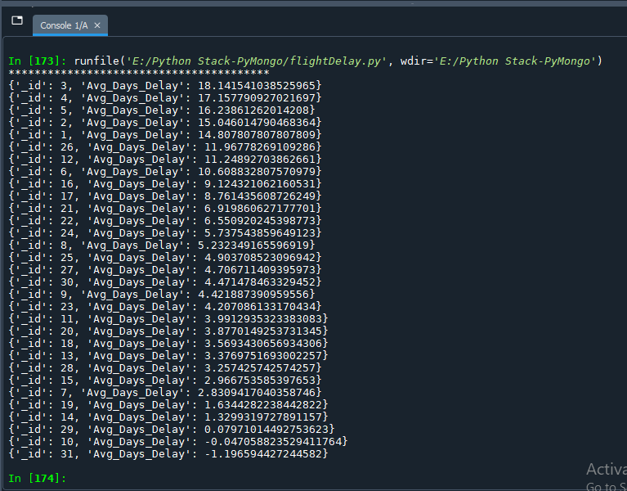

Graph Plot:
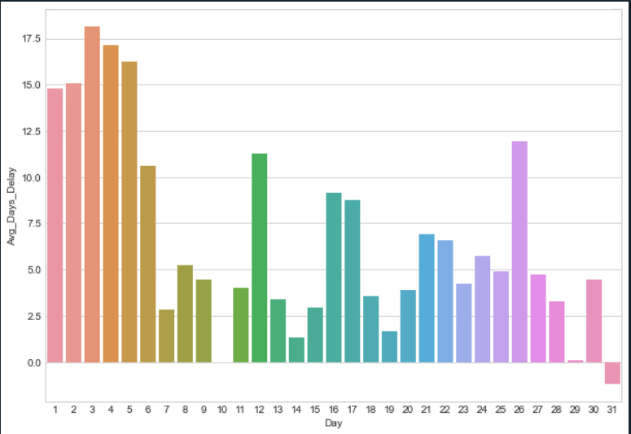
d)
Terminal Output:
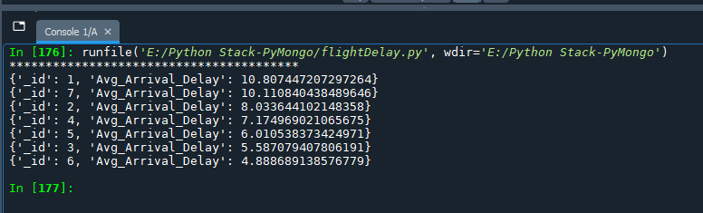

Graph Plot:
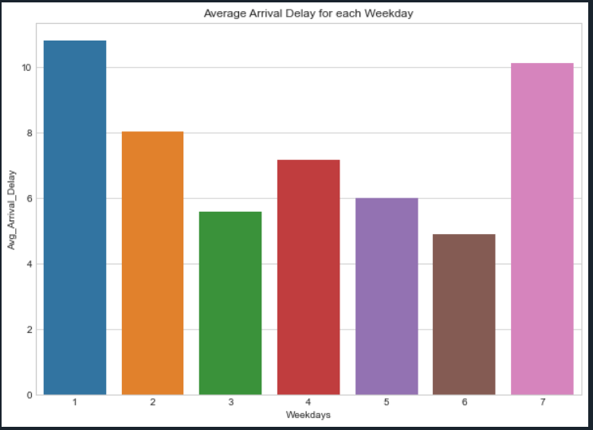

e)
Terminal Output:
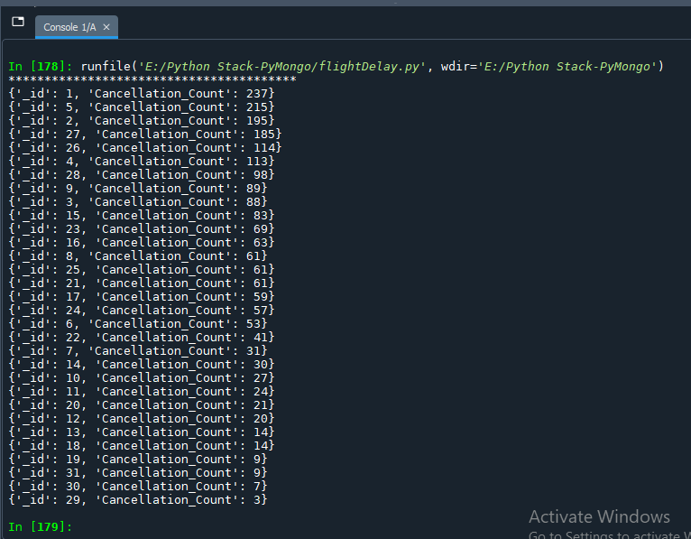
Graph Plot:
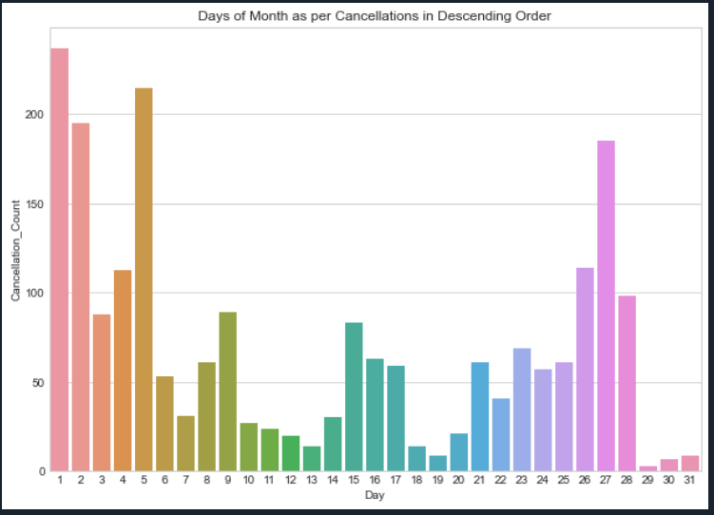
f)

g)
Terminal Output:
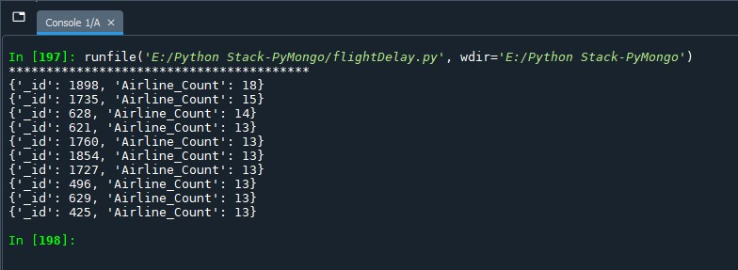
Graph Plot:
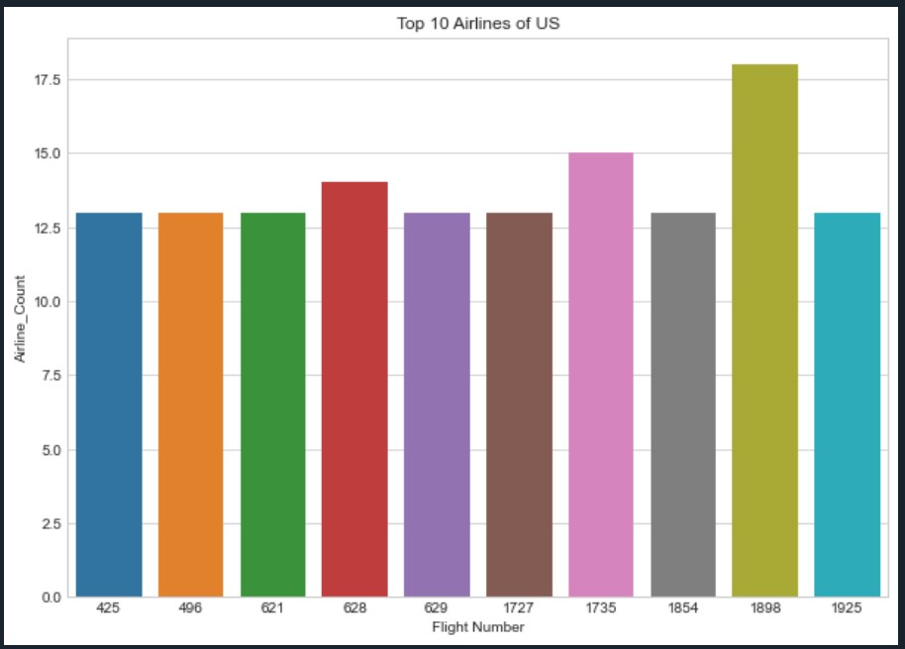

h)
Terminal Output:
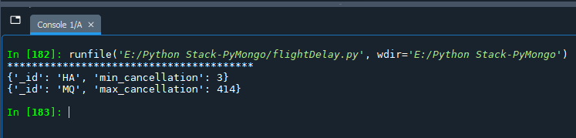

i)
Terminal Output:
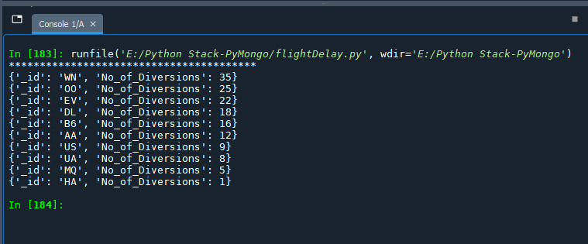

Graph Plot:
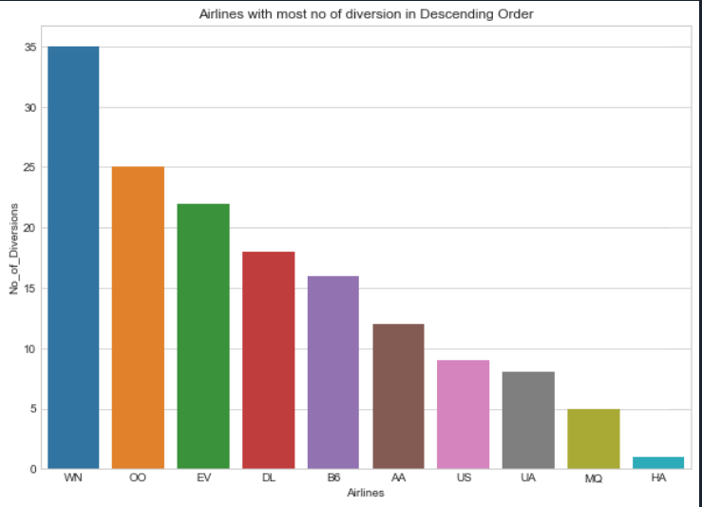

j)
Terminal Output:
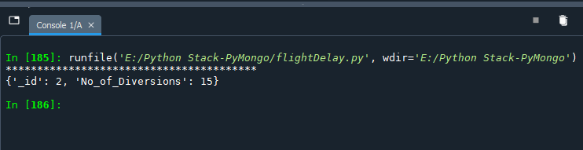

k)
Terminal Output:
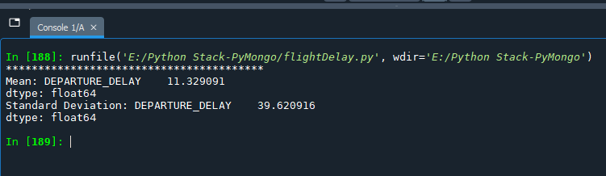
l)
Terminal Output:
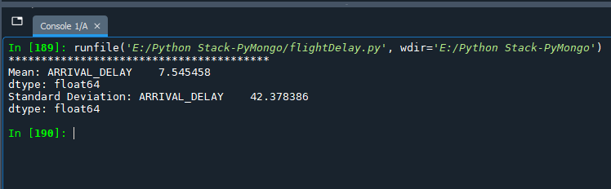

n)
Terminal Output:
i)
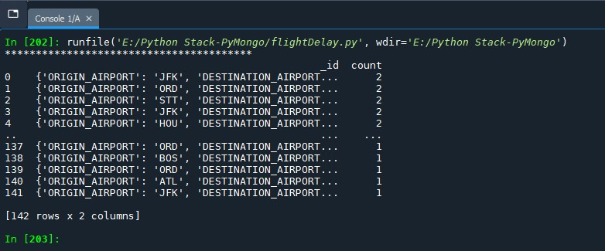
ii)
